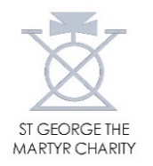
Connected at Christmas Fund 2021 Report
- Overview
For the second year running, the two large Christmas parties (at Guys Tower and Bacon’s College) open to older and vulnerable people in Southwark were cancelled due to the Covid pandemic. These parties are generally a really important event for hundreds of people who often don’t have friends or families to spend Christmas with. Loneliness and isolation across the borough (and the country) increased hugely in the 18 months from the first lockdown in 2020 and once again local charities – and the council – explored ways to reach out to those in most need over the Christmas 2021 season.
In 2020, London Borough of Southwark (LBS), United St Saviour’s Charity (UStSC) and St George the Martyr Charity had come together to pool resources into a ‘Connected at Christmas’ fund. This was supplemented by contributions from other funders, residents and businesses, and benefitted over 4,000 residents, thanks to the extraordinary efforts of many local charities and community groups. The energy and capacity to develop and co-ordinate a programme at the scale and complexity of that delivered in 2020 was not feasible. However when it became clear that the parties would, again, no longer go ahead because of the increasing levels of Covid transmission, the voluntary and community sector were once again concerned about those who may be alone at Christmas. There was appetite to set up a pooled fund which would help groups across the borough to deliver a range of festive activities enabling older and vulnerable people to feel cared for over the Christmas 2021 season.
The overall programme aim was that older and vulnerable Southwark residents, who were likely to be spending Christmas on their own, felt cared for and connected at Christmas.

- Partners
Partners and contributors to the 2021 Connected at Christmas Fund were LBS (£20,000), UStSC (£10,000), Southwark Charities (£10,000), St George the Martyr Charity (£8,000). The total fund was £48,000. LBS made a further contribution of £5,000 to Southwark Group of Tenants Organisations to support activities by local Tenants & Residents Associations.
3. Governance and Processes
The programme was developed in discussion with LBS and a number of local charities, including the Ageing Well Partnership.
Programme funds were held, managed and dispersed by UStSC. Contributing partners, UStSC and St George the Martyr Charity, liaised frequently to ensure that grants made were in line with the programme priorities and beneficial areas of the respective funding partners.
Meetings were held weekly with the Connected at Christmas working group, convened by LBS, to co-ordinate the programme. The programme was based on a competitive process which involved completion of a simple application form available from UStSC’s website. The fund was launched on 18 November 2021 and the link to UStSC’s application form was shared by Southwark Council and Community Southwark with its contacts.
UStSC compiled an email mailing list of all charities, community groups and sheltered housing schemes working with older and vulnerable people across the borough and proactively contacted them with an invitation to apply to the Programme. Community Southwark’s website provided further opportunities for individuals to get involved through volunteering for, and making a charitable donation to, voluntary and community organisations.
4. Funding Awarded
The fund was launched on 18 November 2021. In around 4 weeks prior to Christmas, UStSC had awarded and paid 46 grants, to 45 different groups, totalling £46,133. The charts below show the distribution of the grants by nature of applicant, and the geographical distribution.

- Population groups: 58% of the total amount awarded targeted ‘older people’, compared with 51% last year. 33% supported financially vulnerable people and families and 9% was towards activities for physically or mentally vulnerable adults.

- Equalities: 24% of the total amount awarded went to activities that were specifically focussed on BAME communities. However, most of the grants went to organisations working at neighbourhood level with people from diverse backgrounds and cultures.

- Grant sizes: the average grant size was £1,003. The single largest grant was £3,000 to Southwark Group of Tenants Organisation to support a fund totalling £8,000 (with LBS co-funding of £5,000) for member TRA’s to provide Christmas gift vouchers, goody bags, hampers, meals, winter warmth packs and parties for vulnerable social housing residents. The smallest grant was £140 to Bede House towards an outdoor Christmas party and singalong with Learning Disabilities Service clients. Most of the grants awarded were £1,000 or below.
Grants awarded
Appendix 1 provides more information on the grants that were awarded.
5. Activities and Impact
Connected at Christmas enabled 6,607 individual older and vulnerable people to receive contact, support or to take part in festive activities over the Christmas period.
This included:
46 grants for festive activities to 45 local charities, community groups & TRA’s and sheltered housing providers / care homes.
1,481 Christmas hampers, packages, presents, gifts and goody bags delivered to older and vulnerable people across Southwark.
1,347 Christmas lunches and meals provided to older and vulnerable people, including sheltered housing residents. This includes around 600 Christmas meals prepared by The Borough Food Co-operative at St George the Martyr Church in its kitchen and made available for collection or delivered by its volunteers.
1,090 food parcels provided to financially vulnerable people in Southwark during the Christmas period.
725 older and vulnerable residents attended small scale or online Christmas parties. The smaller face to face events were being run for the first time since 2019, and provided much needed fun and laughter after an incredibly challenging last two years.
934 residents benefitted from other Christmas activities, including 654 vulnerable residents who benefited from gift vouchers, and 120 people with mental distress joining online arts activities.
£3,000 provided in match funding to the Southwark Group of Tenants Organisation to support many TRA’s across the borough to reach vulnerable and older residents living on LBS housing estates. This included food, gifts, vouchers and other festive activities.
6. Beyond Grants
Once again, the Connected at Christmas programme went beyond just the provision of grants. The Southwark Mayor’s Office convened a special Connected at Christmas service, hosted by the Mayor of Southwark from Southwark Cathedral, and broadcast live on You Tube. The candle-lit service highlighted the great work of local charities and community groups in supporting older and vulnerable people during the festive period, and featured readings from representatives of funded organisations, carols beautifully sung by the cathedral choir, and a specially designed Christmas wreath with logos of Connected at Christmas partners and funded organisations.
The Connected at Christmas working group, comprising LBS, UStSC, Community Southwark and local partners, met online each week in the run up to Christmas to co-ordinate publicity for the Programme and review disbursement of funds.

7. Case studies
Case Study 1: Flashy Wings Ministry, Camberwell

Flashy Wings Ministry is a small, volunteer-run, charity led by Queen Ekuerhare (pictured, in festive spectacles) who is embedded within the community in Camberwell and Peckham. ‘Flashy Wings’ provides regular coffee mornings, online sessions and recreational activities for Southwark women, predominantly from the Black community, that are confronting the twin obstacles of isolation and low income.
A Connected at Christmas grant enabled Flashy Wings to host a festive fun social evening and three course meal for its clients at Camberwell restaurant FM Mangal. Queen Ekuerhare said.
‘Our party was a time of joy and togetherness for our service users who are going through difficult times. Thank you for making our Christmas really special’.

Case Study 2. Westminster Youth Club, Nunhead & Peckham  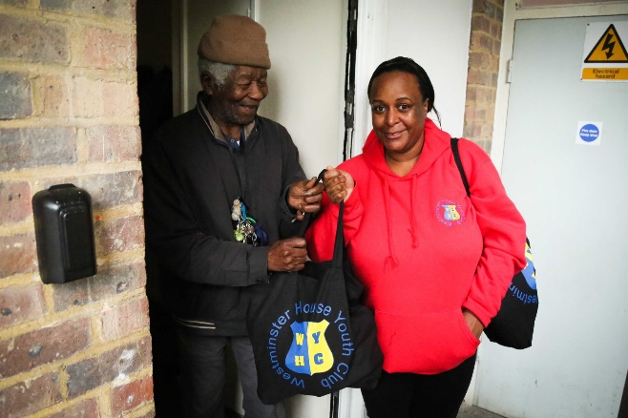 | 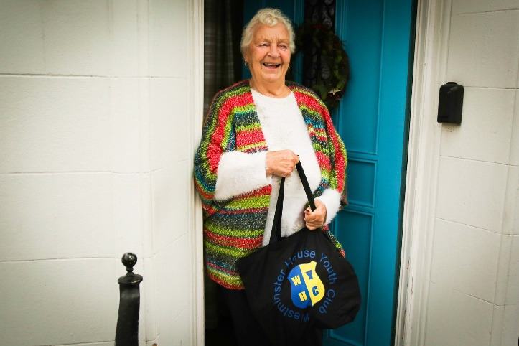
Based in Nunhead, Westminster House Youth Club provides recreational and educational activities for Southwark young people aged 8-18 years and supports them to make positive life choices.
During the first covid-19 lockdown, many local older people in Nunhead and Peckham had become known to the Club through its meals delivery. A Connected at Christmas #2 grant enabled the Club to prepare special Christmas parcels of food items, treats and toiletries which were taken to the older people by the Club’s members. The Christmas bags helped to make the festive period more special for the older people after such a difficult 18 months.
Katie Worthington, the Club’s Director, tweeted on 19th December 2021.
‘The team had so much fun today delivering #GoodyBags to some of our older neighbours! Big thanks to @UnitedStSaviour for funding and #youngpeople for helping to pick and pack! #ConnectedatChristmas #Nunhead’

Case Study 3. Bede House, Bermondsey & Rotherhithe
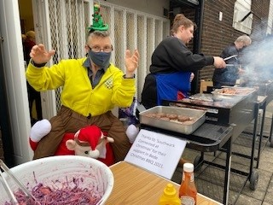
Bede House is a long established community charity based in Bermondsey and Rotherhithe. Its Learning Disabilities service builds the skills and confidence of people with a learning disability through social activities, training, volunteering and employment programmes.
A Connected at Christmas grant enabled Bede to provide a Christmas barbeque and party for its Learning Disabilities service clients that have had to endure nearly two years of lockdowns, social bubbles and community meet ups. The party enabled clients to have fun, play games and see their friends while enjoying a sing along with musicians from the Royal Albert Hall Engagement team.
Carole Brady, Bede’s Service Manager, said.
Our clients had a great Christmas BBQ, complete with games and singing. They also made Christmas Wreaths to take home. Colleagues said we should try this again next year even if we are completely Covid Free! Truly was a lovely day! We actually forgot about Covid for a least an hour!

Case Study 4. Southwark Group of Tenants Organisation, Southwark-wide  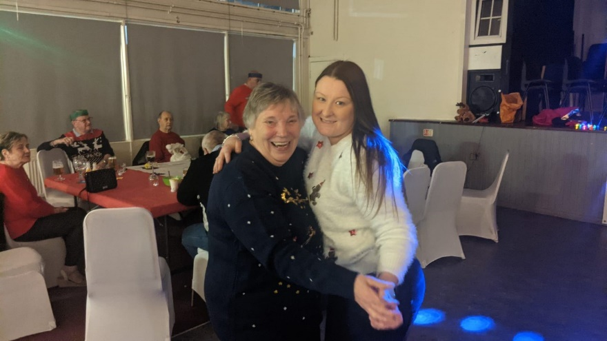 | 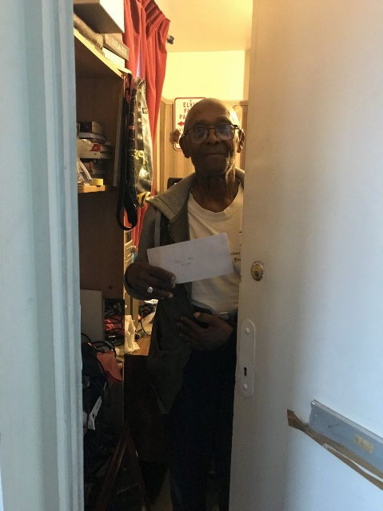
Southwark Group of Tenants Organisation (SGTO) is a federation of Tenant and Resident Associations (TRA) in Southwark, representing and promoting the rights of TRA’s to improve the lives of tenants and residents across Southwark.
As Margaret Onwuta, SGTO’s Senior Manager, puts it.
‘We have realised how very lonely and isolated some of our members are during this time of the year. The youngest member in some of our Tenants and Resident’s Associations is 74 years and there are some without spouses or partners spending most of their time alone each day because it is too cold and dark to go out and join the queue for Christmas shopping.’
A Connected at Christmas grant of £3,000, together with £5,000 from LBS, provided an £8,000 funding pot administered by SGTO. Its member TRA’s could apply for a variety of Christmas activities to put a smile on the faces of older and vulnerable tenants and residents living in social housing. In all, 23 member TRA’s were awarded funds through SGTO’s fund, providing gift vouchers, goody bags, hampers, meals, winter warmth packs and parties to 641 older and vulnerable Southwark residents.
A Southwark tenant said.
‘Thank you for the Xmas gifts. This is so kind, this year has been quite hard but you have made my Christmas special.’
The Bermondsey Street Tenants & Residents Association, said.
We decided to give residents on the estates a little extra something by way of a voucher to make Christmas a little bit more special and we asked everyone to let us know of the very elderly or those not well that we could help. Overall it was a lovely, festive success and helped much in raising awareness of our TRA and that we are here. Our thanks to SGTO and Southwark for the funding help to make it possible – from the worse of Covid times there was a little bit of Christmas joy shared to end 2021.’

8. Continuation of the Fund
As the two large Christmas parties for older Southwark residents are unlikely to return, thought will need to be given to continuing the annual Connected at Christmas Programme to support older and vulnerable Southwark. In years 2020 and 2021, the planning for the programme was quite late in the day, as (in both years) there was an expectation that the pandemic restrictions would have been released in time for Christmas. If the fund were to continue, a longer lead in time and earlier funder commitments will be needed.
9. Conclusions
Connected at Christmas is more than just a grants programme. For the second year running, multiple partners came together to pool resources and co-ordinate activities – the Council, funders, charities and Community Southwark. UStSC and partners moved nimbly to assess and approve grants, assessing and awarding over £46k in just four weeks prior to Christmas. Unlike 2020, this year’s programme included face to face events such as small parties. The spread of the covid variant Omicron in December meant that organisations had to put additional safeguards in place for staff, volunteers and clients including lateral flow tests, mandatory face masks, hand sanitiser use and restrictions on event capacities.
With a total of 6,600 people benefitting from Connected at Christmas activities overall it was a great success and made a lot of older and vulnerable Southwark residents feel cared for after a hugely difficult last 2 years.
As Margaret Onwuta, SGTO, succinctly puts it.
‘Connected at Christmas has highlighted how small acts of caring and showing kindness to those that really need it can be appreciated, especially those vulnerable without a family network apart from few kind neighbours.’
Matthew Allgood, UStSC, 7th February 2022
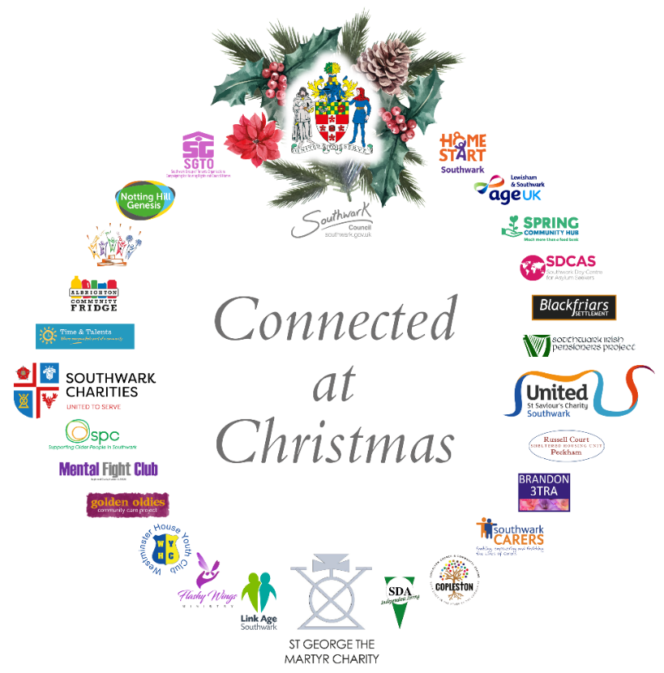

Appendix 1: Southwark Connected at Christmas Fund 2021: Grants awarded
Who was funded | Summary | Grant Awarded
COPSINS Consortium | The Consortium of Older People's Services in Southwark (COPSINS) comprises 6 local charities: Age UK Lewisham and Southwark, Blackfriars Settlement, Link Age Southwark, Southwark Carers, Southwark Pensioners Centre and Time & Talents. The grant will help the COPSINS charities to meet additional needs for older people and carers this Christmas, including:  - Christmas events and outings so that the older people can celebrate coming back together  - Goody bags to distribute to some of the most vulnerable older people  - In person Christmas lunches and prepared meals delivery  - Online Christmas Party and entertainment for Carers and their families  - Christmas Day and New Year’s Day Zooms  - Intergenerational activities - children creating cards, wreaths and a gift for older people. | £ 6,000 (£1,000 per COPSINS charity)
Walworth Golden Oldies Community Care Project | Based at Walworth Methodist Church, Golden Oldies provides a day centre providing fun social activities and befriending for mainly Caribbean older people. Golden Oldies are receiving a grant to provide their highly anticipated Christmas show and Party including costs of entertainment, provision of a traditional Caribbean Christmas lunch; plus Christmas goody bags to older people, including suitable toiletries, goodies and food. | £ 1,950
Southwark Group of Tenant Organisations (SGTO) | SGTO is the infrastructure body that represents, promotes and advocates for Tenant and Resident Associations (TRA) across Southwark. The grant has provided match funding to increase the size of a fund set up by SGTO with LB Southwark grant to enable individual TRA’s to support older and vulnerable residents at neighbourhood level. Funds can be used to provide items, vouchers, or activities, especially to those living alone so they feel cared for and connected at Christmas. | £ 3,000
East Dulwich Estate Tenants & Residents Association / Albrighton Community Centre | The grant will provide 250 – 300 food parcels to people on low / no incomes attending the Albrighton Centre’s Community Fridge. This will help them manage over the Christmas and New Year period when they will have less access to food support due to seasonal closures of the Community Fridge and other organisations they may look to for food support. | £2,000
Spring Community Hub | The Hub will provide Christmas Hampers filled with festive treats to the older people that attend its services (and who do not meet the criteria for the Hub’s Christmas Hamper Appeal which is for families with young children). The older people would normally celebrate Christmas with their extended families and those who normally attend local groups to celebrate however, due the continuing rise in the COVID-19 outbreak locally they will be spending Christmas alone. | £900
Brook Drive Sheltered Housing Unit | Brook Drive is a sheltered housing unit near to the Imperial War Museum. The grant will provide Christmas hampers for 38 sheltered housing residents. | £917
Grosvenor Sheltered Housing Unit | Grosvenor Park is a sheltered housing unit in the 'triangle' between John Ruskin Street, Camberwell Road and Camberwell New Road. The grant is supporting an in-house get together enabling the sheltered housing residents to share some food, listen to music and have fun. It will give them a chance to socialise especially as it was not possible to do this last year. | £500
King Charles Court Sheltered Housing Unit | King Charles Court Sheltered Housing Unit is based in Walworth, near Kennington Park, housing older residents on low incomes who don't have friends and family nearby. The grant will provide a Christmas party and evening meals for residents and their friends. They are looking forward to seeing each other again after a long period of being in isolation. | £1,000
Southwark Irish Pensioners Project | The grant will support Christmas goody bags to 166 pensioners who are resident in the SE1 and SE16 postcodes of Southwark. | £1,660
Russell Court Sheltered Housing Unit | Russell Court is a Sheltered Housing Unit based in Peckham, housing 30 mainly vulnerable older residents. The grant will provide a full Christmas lunch in packed form prepared and delivered by a recognized caterer, and includes vegetarian options. | £750
Brandon 3 Tenants & Residents Association | The grant will support (1) a choral service outdoors on the Brandon 3 Estate, with refreshments available outside and in the TRA hall. (2) – a sit-down afternoon tea party with hot food and drinks to help older residents, carers and young families who are financially struggling socialise. Each resident will be given a Christmas food parcel, and further parcels will be delivered to those that are housebound or still not comfortable mixing with others. | £1,000
Conrad Court Extra Care Home, Surrey Quays | Conrad Court is an Extra Care Home in Surrey Quays managed by Notting Hill Genesis. The grant will provide a Christmas gift to 20 residents at the Home who do not have family or rarely see family members or friends. | £200
Copleston Centre | Copleston is a multi-purpose community centre between Peckham and East Dulwich. The grant will provide 100 seasonal goody bags for older people including warm and well information sheets; seasonal socials and Christmas meals in community café. | £1,170
Flashy Wings Ministry | The grant will provide a 3 course Christmas meal and raffle for the Charity’s service users – older and vulnerable women - that are going through difficult times. | £650
Kingswood Estate Tenants & Residents Association | The grant will provide Christmas hampers for 50 older residents on the Kingswood Estate in West Dulwich. The lockdowns and restrictions caused by the covid-19 pandemic has led to a prolonged period of isolation for older and vulnerable residents and the hampers will restore festive cheer. | £1,000
Southwark Disablement Association | The grant will provide Christmas dinner parties for the Charity’s service users – disabled adults, their carers and volunteers. | £400
Mental Fight Club | The Mental Fight Club is a creative group which supports Southwark residents who have experienced mental illness, through its flagship programme the Dragon Café. It is providing online workshop activities over the festive season which facilitate vulnerable members of the community coming together for fun and creative sessions. For some participants it may be the only group activity they are able to attend during the festive season due isolatory factors including covid-19. | £1,389
Home Start Southwark | Home Start Southwark works with very vulnerable low income families across Southwark. The grant will provide trips to the Haymarket Theatre and Blue Elephant Theatre for vulnerable families who would ordinarily not be able to afford to go. | £1,693
Westminster House Youth Club | Westminster House is a youth club in Nunhead. The grant will provide parcels of food items, Christmas treats and toiletries to vulnerable older residents in Nunhead and Peckham, delivered by the Charity’s young volunteers. | £1,900
Hughes House Sheltered Housing Social Club | Hughes House is a Sheltered Housing Unit on the Newington Estate near Elephant and Castle. Many of its sheltered residents do not have family and will spend Christmas alone. The SHU will provide a Christmas meal and drinks for all the residents to sit together and enjoy. | £450
Bede House | Bede House is a multi-purpose community centre and settlement in Bermondsey and Rotherhithe. Its learning disabilities clients have had nearly two years of lockdowns and overwhelmingly want an outdoor ‘party’ where they can sing, dance and see friends - a singalong has been organised with the Royal Albert Hall Engagement team and there will be a Christmas barbeque! | £140
Draper Together | Draper Together is a community charity that operates for the benefit of residents in and around the Draper Estate in Elephant and Castle. The charity is organising a party for older residents in the Draper Hall, with games and fun activities including a DJ. | £750
Astley & Cooper’s Road Estate Tenants & Residents Association | Astley & Cooper’s Road is a large social housing estate along the Old Kent Road, in SE1. The TRA will deliver Christmas hamper parcels to the doorsteps of 100 senior citizens and vulnerable residents during the Christmas period. | £1,999
Elimhouse Community Association | Elimhouse is a day centre for BAME older people in Peckham. The grant will deliver a Christmas party for the older people, plus outreach when the day centre closes over Christmas (23 December – 3 January) through telephone support and delivery of food parcels to the older people. | £800
Blackfriars Settlement | The grant will provide meals delivery for the Settlement’s mental health service users who are very isolated and vulnerable over the holiday period. | £250
Look Ahead Care and Support | Look Ahead is a charitable social housing association that provides housing, care, and support to some of most vulnerable individuals and families across Southwark. The grant will provide Christmas meals, festivities and small gifts to vulnerable people that use its hostels in Southwark. | £1,000
Lordship Lane Baptist Church | Based in East Dulwich, the Lordship Lane Baptist Church provides a lunch club and befriending service for African and Caribbean older people. They are being funded to deliver a culturally appropriate Christmas lunch with Christmas carols. | £1,500
Rye Hill Tenants & Residents Association | Rye Hill Tenants Association in Rye Lane have run a food bank since the covid-19 pandemic. They have been funded to provide food parcels to low-income residents on their Estate, and food bank users, during the Christmas period. | £1,500
Restorative Justice For All | RJ4All has been running the Rotherhithe Community Centre near Surrey Quays for the last year. The grant will provide 3 Tea and Christmas cake events for local older people to come together and socialise at the Centre. | £450
Latin American Disabled People’s Project | The grant will provide a Christmas get together and feast for 25 older and disabled Latin American people at the charity’s centre in Elephant & Castle. | £600
Consort Sheltered Housing Unit | Consort is a sheltered housing unit in Peckham. The grant will provide Christmas hampers for its 30 sheltered housing residents. | £310
Guinness Trust Estate Tenants Association, Pages Walk | The Guinness Trust Estate is at Pages Walk by the Old Kent Road. The Tenants Association will deliver hot food to the doors of 33 Estate pensioners and there will be refreshments and raffle prizes enabling people to socialise in the Estate’s communal room. | £400
Coin Street Centre Trust | Coin Street is a large community centre serving residents from Southwark and from Lambeth. The grant is contributing to a late Christmas party for local older people, of which 55 are from Southwark, including a full three course hot meal and entertainment at Coin Street’s Neighbourhood Centre. | £1,400
Nunhead Green Community Centre | The Green is a community centre in Nunhead. The grant is supporting a Christmas party for 35 members of its Ivy Club, including older people and people with disabilities, which for some is the only Christmas celebration they get to share in. | £385
Disability Sports Coach | The grant will support a virtual Christmas club for people with disabilities at a time of year which is often isolating as well as a sports programme. | £790
Dockland Settlements | The charity will provide 90 Christmas gift bags for residents of Barnards House Sheltered Housing, and older people using Dockland Settlements Rotherhithe Centre and Millwall F.C. services. | £900
Celestial Church of Christ Amazing Grace Parish Peckham | Celestial Church Peckham will provide 42 Christmas hampers for 30 families with No Recourse to Public Funds and 12 older people who would be on their own this Christmas. | £520
Pembroke House | The grant will provide a Christmas message and £3 voucher to 320 vulnerable people that received food parcels from Pembroke’s Food Hub in 2021. The vouchers will be redeemable at the Walworth Living Room café when it opens in the New Year. | £960
St George the Martyr Church | The Church, which played a pivotal role in last year’s Connected at Christmas Programme, is this year providing free hot meals for 600 vulnerable and low-income families on 22nd December from its crypt kitchen. | £700
City Hope Church | City Hope is a lively Church and charity based in Bermondsey. The grant will provide Christmas hampers for 70 vulnerable people and families that use its foodbank and debt advice services. | £1,750
Children and Families Empowerment Foundation | Based at Walworth Methodist Church, the charity has provided foodbank services during the pandemic to families and children from Black African and Black Caribbean communities in Southwark. The grant will provide for hot meals delivery to 8 older people, and Christmas gifts and hampers to 25 vulnerable families. | £500
 | Total: 46 grants | £46,133

